WELNESS
Work: (Ministry) Enjoying ministry. Appreciating your skill, talents and gifts. This dimension of wellness recognizes the importance of satisfaction, enrichment and meaning through your ministry.
Emotional: involves accepting and exploring who you are, enhancing your inner resources to reduce stress and maintaining a positive outlook on life.
Lifelong learning: Being engaged in creative, stimulating mental activities expanding your knowledge and skills, and using your talents to help others and solve problems.
Nurturing Relationships: Giving and receiving support through relationships.
Exercise & Physical Wellness: is about creating opportunities for healthy eating, active living and self-care practices that will support your health and wellness.
Spiritual: Growing as a spiritually healthy leader. Have a Spiritual health plan. Have a daily habit of being with God through prayer and scripture not for the purpose of prep or your appointment but for your own spiritual life.
Stewardship: Living a generous life with the resources God has given you. Living within your means and managing finances for the long & short term.

WELNESS Wheel Worksheet to be printed Version 9.5

Step one Instructions
The 7 sections represent 7 dimensions of well-being.
- Take the centre of the wheel as the lowest level with the outer edge as highest, objectively as you can, score each area by drawing a line to create a new outer edge (see example)
- The new perimeter of the circle represents your “wheel of welness.” Is it a bumpy ride?
EXAMPLE

8

9

7

2

4

5

8

6

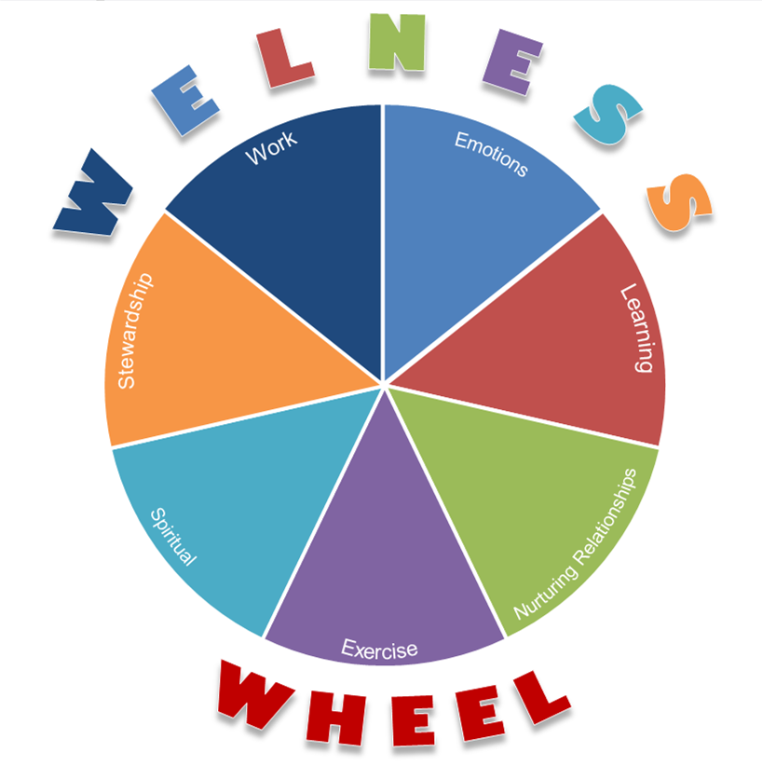

Name: Date:

Wellness is an active process of becoming aware of and making choices toward a healthy and fulfilling life. Wellness is more than being free from illness, it is a dynamic process of change and growth. - University of California, Davis USA

WELNESS WHEEL
- Mark ( see back page for instructions)

10
9
8
7
6
5
4
3
2
1
Work
10
9
8
7
6
5
4
3
2
1
10
9
8
7
6
5
4
3
2
1

1
2
3
4
5
6
7
8
9
10
Nurturing Relationships
Stewardship

Emotional

Exercise
Learning

Spiritual

10
9
8
7
6
5
4
3
2
1

1
2
3
4
5
6
7
8
9
10

1
2
3
4
5
6
7
8
9
10

2. Reflect
- What could I do More of…
- What could I do Less of…
- What could I Start doing…
- What could I Stop doing…
- What am I doing Well at…

- SMART Goals
Set SMART goals for the top 2 or 3 dimensions that will help improve your wellbeing. (This is a Qld requirement for taking compassionate leave over 7 days)
W
E
L
N
E
S
S
Tip: Refer to the WELNESS Wheel Resource booklet for suggestions of books, online resources, and services.
4. Accountability
Review these goals with your Line manager or delegate

